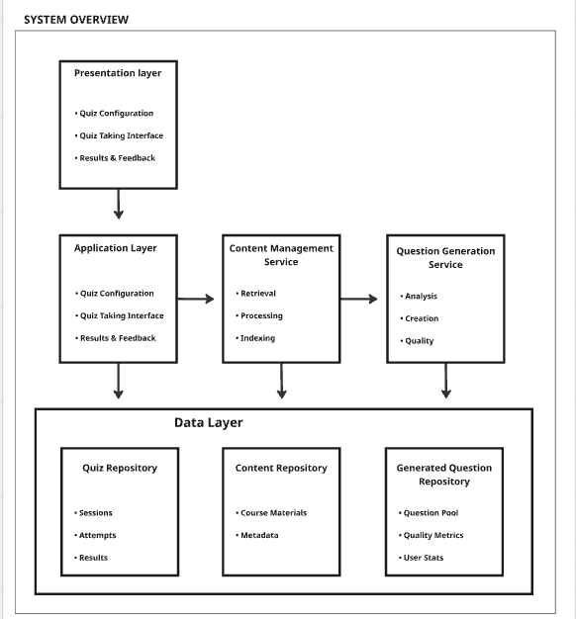

Architectural Patterns
- Layered Architecture: Clear separation between presentation, application, and data layers
- Service-Oriented: Distinct services for content management and question generation
- Repository Pattern: Abstracted data access through repositories
- Event-Driven: Asynchronous processing for resource-intensive question generation
Key Architectural Decisions
- Scalability: Question generation service can be horizontally scaled independently
- Loose Coupling: Services communicate through well-defined interfaces
- Data Consistency: Eventual consistency model for generated questions
- Caching Strategy: Multi-layer caching for content and generated questions
Integration Points
- Authentication: Inherits from existing user management
- Content Access: Read-only integration with existing course content
- Progress Tracking: Optional integration with portal gradebook/analytics
Non-Functional Considerations
- Performance: Response time < 3 seconds for quiz generation
- Availability: 99.5% uptime during business hours
- Scalability: Support 500 concurrent quiz generations
- Security: Role-based access control, content access validation

